**CNSL Lab Assignment 5**

**Neeti Kurulkar**

**Write a program to demonstrate Sub-netting and find subnet masks.**

**Code :**

**import java.util.Scanner;**

**import java.net.InetAddress;**

**public class cnl_5a {**

**public static void main(String args[]){**

**Scanner sc = new Scanner(System.in);**

**System.out.print("Enter IP Address: ");**

**String ip = sc.nextLine();**

**String split_ip[] = ip.split("\\."); //split the ip address**

**//convert IP Adress to binary**

**String split_bip[]= new String[4];**

**String bip = "";**

**for(int i=0;i<4;i++) {**

**split_bip[i] = appendZeroes(Integer.toBinaryString(Integer.parseInt(split_ip[i])));**

**bip += split_bip[i];**

**}**

**System.out.println("Binary IP Address: " + bip);**

**//find subnet mask**

**System.out.print("\nEnter the number of address: ");**

**int n = sc.nextInt();**

**int bits = (int)Math.ceil(Math.log(n) / Math.log(2));**

**System.out.println("\nThe number of bits required = " + bits);**

**int mask = 32 - bits;**

**int total_address = (int)Math.pow(2, bits);**

**System.out.println("Subnet mask is : " + mask);**

**//Calculate First Address**

**int fbip[] = new int[32];**

**for(int i = 0; i < 32; i++){**

**fbip[i] = (int)bip.charAt(i) - 48; //convert char -> int**

**}**

**for(int i = 31; i > (31 - bits); i--){**

**//Get first address by ANDing the last bits with 0**

**fbip[i] &= 0;**

**}**

**String fip[]={"","","",""};**

**for(int i = 0; i < 32; i++){**

**fip[i/8] = new String(fip[i/8] + fbip[i]);**

**}**

**int first_offset = 0;**

**int ipAddr[] = new int[4]; ;**

**System.out.println("\nGroup 1 \nThe First Address is:");**

**for(int i = 0; i < 4; i++){**

**System.out.print(ipAddr[i] = first_offset = Integer.parseInt(fip[i], 2));**

**if(i != 3)**

**System.out.print(".");**

**}**

**System.out.println();**

**//Calculate Last Address**

**int lbip[] = new int [32];**

**for(int i = 0; i < 32; i++){**

**lbip[i] = (int)bip.charAt(i) - 48; //convert char -> int**

**}**

**for(int i = 31; i > (31 - bits); i--){**

**// Get last address by ORing last bits with 1**

**lbip[i] |= 1;**

**}**

**String lip[] = {"","","",""};**

**for(int i = 0; i < 32; i++){**

**lip[i/8] = new String(lip[i/8] + lbip[i]);**

**}**

**int ipLast[] = new int[4];**

**System.out.println("The Last Address is: ");**

**for(int i = 0; i < 4; i++){**

**System.out.print(ipLast[i] = Integer.parseInt(lip[i], 2));**

**if(i != 3)**

**System.out.print(".");**

**}**

**System.out.println();**

**System.out.println("\nHow many subnets do you want to form?");**

**int scount = sc.nextInt();**

**for(int j = 1; j < scount; j++){**

**System.out.println("\nGROUP " + (j+1) + " FIRST ADDRESS:");**

**for(int i = 0; i < 4; i++){**

**if(i < 3)**

**System.out.print(ipAddr[i] + ".");**

**else**

**System.out.println(ipAddr[i]= ipAddr[i] + total_address);**

**}**

**System.out.println("GROUP "+ (j+1)+" LAST ADDRESS:");**

**for(int i = 0; i < 4; i++){**

**if(i < 3)**

**System.out.print(ipLast[i]+".");**

**else**

**System.out.println(ipLast[i] = ipLast[i] + total_address);**

**}**

**System.out.println();**

**}**

**//Ping another IP Address**

**try{**

**System.out.println("Enter the Ip address to ping: ");**

**Scanner s = new Scanner(System.in);**

**String ip_add = s.nextLine();**

**InetAddress inet = InetAddress.getByName(ip_add);**

**if(inet.isReachable(5000))**

**System.out.println("The ip address is reachable" + ip_add);**

**else**

**System.out.println("The ip address is not reachable "+ip_add);**

**}**

**catch( Exception e){**

**System.out.println("Exception:" + e.getMessage());**

**}**

**}**

**//function**

**static String appendZeroes(String s){**

**String temp = new String("00000000");**

**return temp.substring(s.length()) + s;**

**}**

**}**

**Output:**

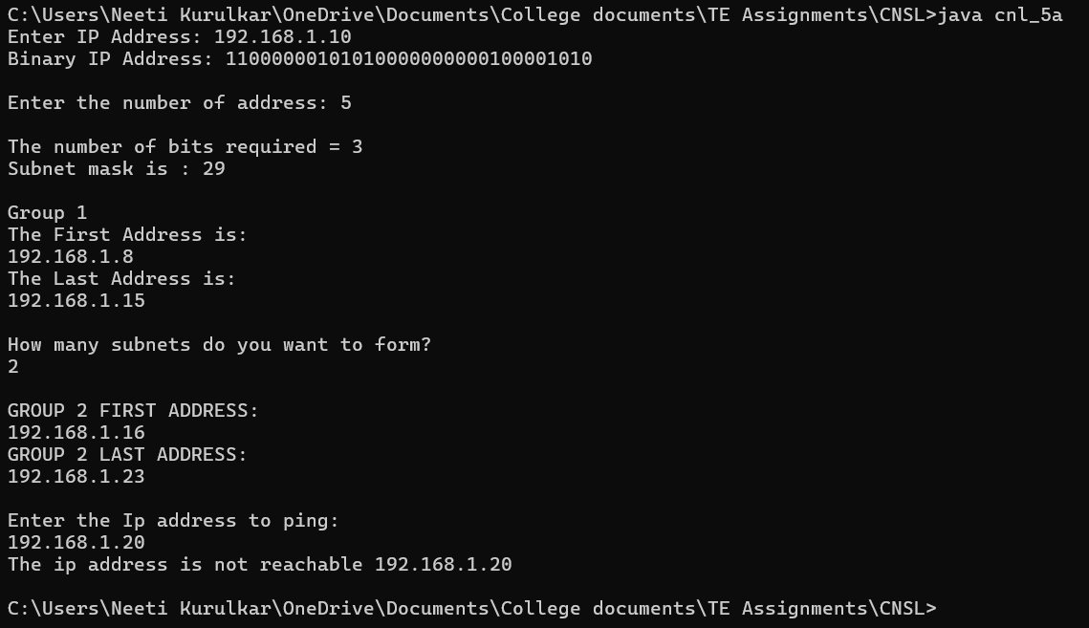

**import java.util.Scanner;**

**public class cnl_5b {**

**public static void main(String[] args) {**

**Scanner scan = new Scanner(System.in);**

**String ip = new String();**

**int mask = 0, defaultmask = 0;**

**System.out.println("enter ip address");**

**ip = scan.nextLine();**

**System.out.println("enter mask");**

**mask = scan.nextInt();**

**String[] splitip = ip.split("\\.");**

**System.out.println(splitip[0] + " " + splitip[1] + " " + splitip[2] + " " + splitip[3] + " ");**

**int first = Integer.parseInt(splitip[0]);**

**if(first >= 0 && first <= 127){**

**System.out.println("CLASS A");**

**defaultmask = 8;**

**}**

**else if(first > 127 && first <= 191){**

**System.out.println("CLASS B");**

**defaultmask = 16;**

**}**

**else if(first > 191 && first <= 223){**

**System.out.println("CLASS C");**

**defaultmask = 24;**

**}**

**else if(first > 223){**

**System.out.println("CLASS D");**

**defaultmask = 32;**

**}**

**String binip = new String();**

**String defmask = new String();**

**for(int i=0;i<4;i++){**

**binip = binip + appendZeroes(Integer.toBinaryString(Integer.parseInt(splitip[i])));**

**}**

**System.out.println("IP in binary : " + binip);**

**System.out.println("Default Mask : " + defaultmask);**

**for(int i=0;i<32;i++){**

**if(i<mask)**

**defmask = defmask + "1";**

**else**

**defmask = defmask + "0";**

**}**

**System.out.println(defmask);**

**String netid = new String();**

**for(int i=0;i<32;i++){**

**netid = netid +**

**(Integer.parseInt(""+binip.charAt(i))&Integer.parseInt(""+defmask.charAt(i)));**

**}**

**int p=-1;**

**System.out.println(netid);**

**String[] net = new String[4];**

**String[] def = new String[4];**

**for(int i = 0; i < 32; i++){**

**if((i % 8) == 0){**

**p++;**

**net[p] = "";**

**def[p]="";**

**net[p] = net[p] + netid.charAt(i);**

**def[p] = def[p] + defmask.charAt(i);**

**}**

**else{**

**net[p] = net[p] + netid.charAt(i);**

**def[p] = def[p] + defmask.charAt(i);**

**}**

**}**

**System.out.println("Given IP : "+ip);**

**System.out.print("subnet mask : ");**

**for(int i=0;i<4;i++){**

**System.out.print(Integer.parseInt(def[i],2));**

**if(i!=3)**

**System.out.print(".");**

**}**

**System.out.println();**

**System.out.print("NetId : ");**

**for(int i = 0; i < 4; i++){**

**System.out.print(Integer.parseInt(net[i], 2));**

**if(i != 3)**

**System.out.print(".");**

**}**

**}**

**private static String appendZeroes(String binaryString) {**

**String temp = new String("00000000");**

**return temp.substring(binaryString.length())+ binaryString;**

**}**

**}**

**Output:**

